PRACTICAL – 03
OPERATING SYSTEMS AND SYSTEM PROGRAMMING
PRACTICAL – 03
Title: Process Creation and Observation of Process State Transitions
Name: Shreyas.K
Roll No.: 2520030119
Course: Operating Systems and System Programming
Practical No.: 03

1. AIM
To develop a C program using fork() to create parent and child processes, display PID and PPID information, and observe process state transitions using Linux monitoring tools such as ps, top, and /proc.
2. OBJECTIVES
- To create a child process using fork().
- To display the PID and PPID of processes.
- To understand parent-child relationships.
- To observe different process states.
- To use ps to monitor processes.
- To use /proc to inspect process information.
- To understand Ready, Running, Waiting, and Terminated states.
3. THEORY
A process passes through different states during its lifetime.
Ready: The process is ready to execute but is waiting for CPU scheduling.
Running: The process is currently executing on the CPU.
Waiting: The process is waiting for an event, resource, or another process.
Terminated: The process has completed execution and is no longer running.
A simplified process lifecycle is:
Ready → Running → Waiting → Ready → Running → Terminated

4. PROGRAM 1
File: process_states.c
The program uses fork() to create a child process and displays the PID and PPID.
5. COMPILATION
gcc process_states.c -o process_states
6. EXECUTION
./process_states
7. PROGRAM 2
File: state_observe.c
This program was used to create a process whose state could be observed using Linux monitoring tools.
8. COMPILATION
gcc state_observe.c -o state_observe
9. EXECUTION
./state_observe
10. LINUX MONITORING TOOLS
ps
The ps command displays information about active processes.
Example:
ps -p PID -o pid,ppid,state,cmd
PID represents Process ID.
PPID represents Parent Process ID.
STATE represents the current process state.
CMD represents the command associated with the process.
11. /proc
Linux provides a virtual filesystem called /proc.
Information about a process can be inspected using:
cat /proc/PID/status
The status file contains information such as:
• Process name
• Process ID
• Parent Process ID
• Process state
• Memory information
• Thread information
12. top
The top command provides real-time information about processes.
Command:
top
It displays process ID, user, CPU usage, memory usage, process state, and running processes.
13. EXPERIMENT PROCEDURE
Step 1: Compile the process creation program.
gcc process_states.c -o process_states
Step 2: Run the program.
./process_states
Step 3: Record the PID and PPID displayed by the program.
Step 4: Use ps to inspect the process.
ps -p PID -o pid,ppid,state,cmd
Step 5: Use /proc.
cat /proc/PID/status
Step 6: Use top.
top
14. OBSERVATIONS
The experiment demonstrates that a process does not remain in one state throughout its lifetime.
A newly created process becomes eligible for execution, enters the running state when scheduled, may enter a waiting state when it waits for an event, and eventually reaches the terminated state after completing its execution.
The ps command can be used to identify the current state of a process.
The /proc/PID/status file provides detailed information maintained by the Linux kernel about the process.
15. OUTPUT
Screenshot 1 – Program Execution
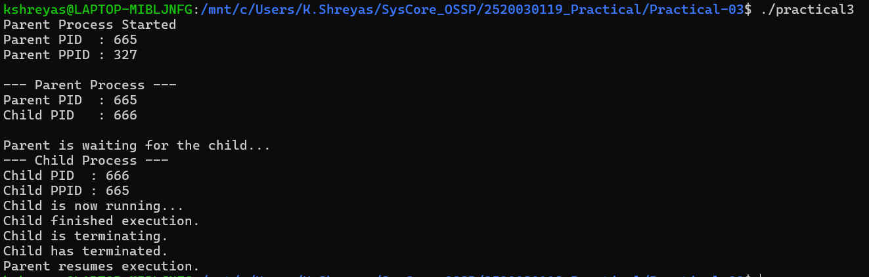
Screenshot 2 – ps
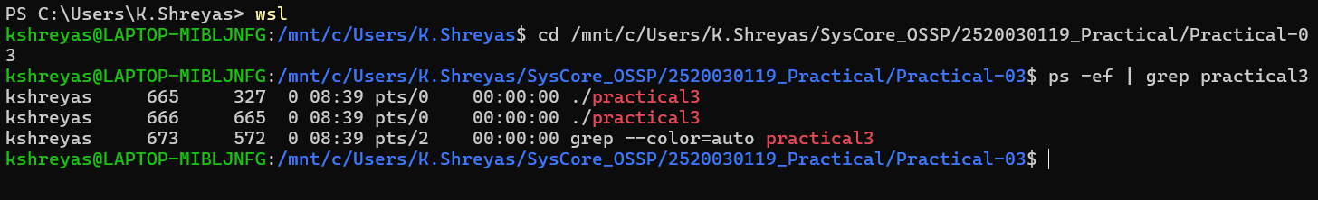
Screenshot 3 – /proc
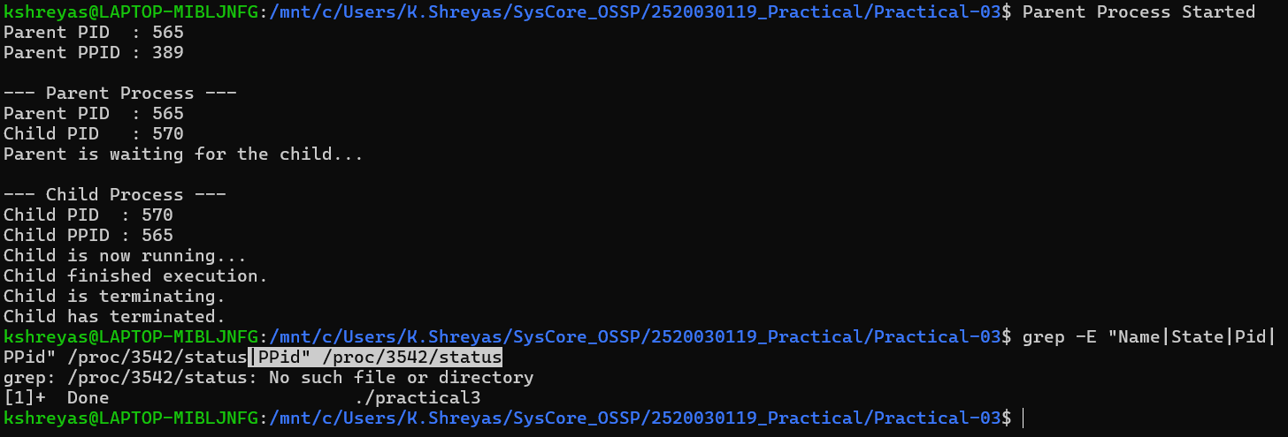

Screenshot 4 – top
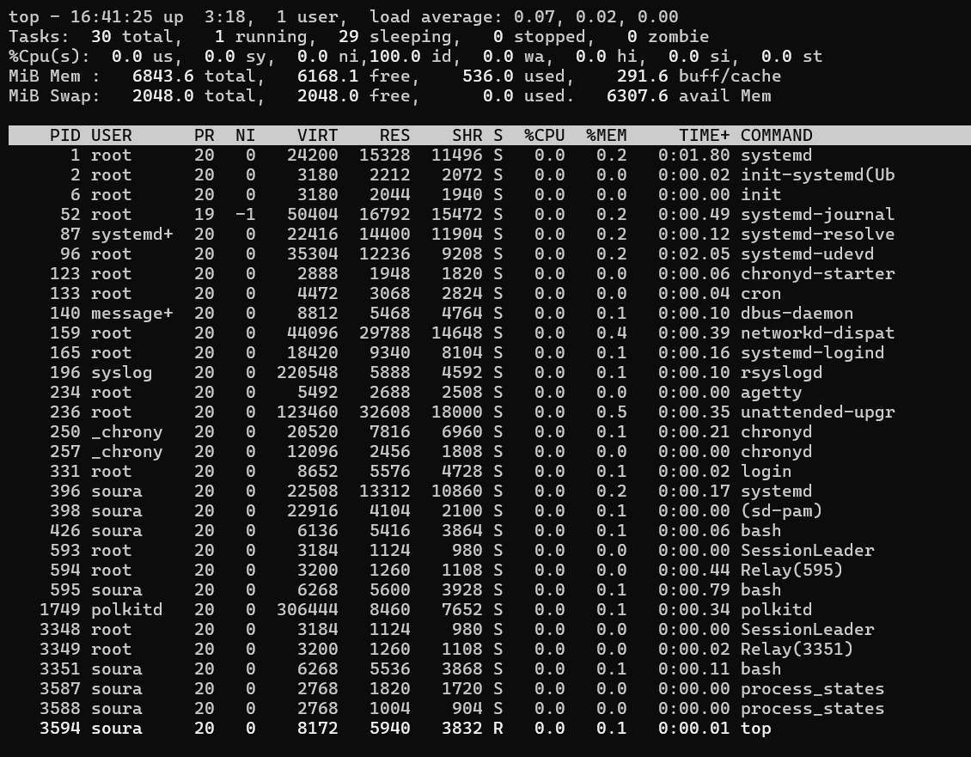16. PROCESS STATE OBSERVATION TABLE
Stage – Expected State – Observation
Process created – Ready/Running – Process becomes available for scheduling.
CPU execution – Running – Process executes instructions.
Waiting for event – Waiting – Process waits for a required event or resource.
Completion – Terminated – Process finishes execution.
17. CONCLUSION
The practical successfully demonstrated process creation using fork() and process identification using PID and PPID. Linux monitoring utilities such as ps, top, and /proc were used to inspect process information and understand process state transitions.

